***Effects of lifestyle factors on the resting heart rate of teenagers***

**Introduction:**

**Cardiovascular health is a significant factor in a teenager’s early life as it can prevent diseases relate to cardiovascular. Cardiovascular health refers to the health of blood vessels and the heart.** **Cardiovascular disease is a group of diseases of the heart and blood vessels. The following information about different type of cardiovascular disease belongs to World Health Organization:**

* **Coronary heart disease – a disease of the blood vessels supplying the heart muscle;**
* **Cerebrovascular disease – a disease of the blood vessels supplying the brain;**
* **Peripheral arterial disease – a disease of blood vessels supplying the arms and legs;**
* **Rheumatic heart disease – damage to the heart muscle and heart valves from Rheumatic fever, caused by streptococcal bacteria;**
* **Congenital heart disease – birth defects that affect the normal development and functioning of the heart caused by malformations of the heart structure from birth; and**
* **Deep vein thrombosis and pulmonary embolism – blood clots in the leg veins, which can dislodge and move to the heart and lungs. (World Health Organization, n.d.)**

**Heart attacks and strokes are usually acute events and are primarily caused by blockages that block blood flow to the heart or brain is the accumulation of fat deposits. A stroke can be caused by bleeding or a blood clot from a blood vessel in the brain. To prevent cardiovascular diseases, factors can be performed or used such as exercising, diets, e.g. The factor that has been chosen in this investigation is exercising (days per week). Heart rate can be measured as BPM (beats per minute). Exercise is physical activity that is planned, structured, and repetitive for the purpose of conditioning any part of the body. Exercise is used to improve health,** **maintain fitness and is important as a means of physical rehabilitation. (The Free Dictionary, n.d.). The average heart rate for teenagers is between 50-90 bpm. This range of heart rate can vary as it does not apply to every teenager. Factors such as high intake of caffeine, bad diets, and mental health can increase the heart rate and their chance of getting cardiovascular diseases. A higher heart rate does not necessarily mean it is “dangerous” but may require medical attention. Regular exercise often results in a resting heart rate decrease of five to 25 beats per minute, according to exercise scientist Len Kravitz, a University of New Mexico professor. With a slower heart rate, the heart's left ventricle has more time to fill with blood and more time to deliver oxygen and nutrients to the body and heart muscle. As a result, the heart becomes more efficient at meeting your body's needs for energy and oxygen(LiveStrong, 2021). This investigation will be investigating how exercise (days per week) will be affecting the resting heart rate (beats per minute).**

**Hypothesis:**

**The greater the days of exercise per week (independent variable) will decrease the heart rate (bpm) of teenagers (dependent variable).**

**Variables:**

**Independent variable: The days of exercise per week**

**Dependent variable: The heart rate of teenagers (bpm)**

**Controlled variables: the stopwatch being used to time the duration of heart rate and the age of the teenagers being in this experiment.**

**Materials:**

**Stopwatch: 1**

**Laptop: 1**

**Google (websites): 1**

**Pen: 1**

**Paper: 1**

**Internet: 1**

**Lines paper: 1**

**19 participants (adolescents)**

**Calculator: 1**

**Ruler: 1**

**Method:**

1. **Set up all your materials by collecting or opening them. Get them ready for the experiment. Double check all materials for any error.**
2. **Find out the variables such as the independent, dependent, and controlled.**
3. **Open a document on your laptop for collecting the data. Set up a data table with titles correctly labelled such as gender, and days of exercise. Do not measure your own heart rate, get someone else to do it for you. Ask your classmates as they all should be the same/similar age as you.**
4. **Ask a classmate to measure your heart rate for 1 min using a stopwatch. Repeat 3 times and find the average of your heart rate (bpm). Input it into your table.**
5. **Start helping other classmates measuring their heart rates following the same controlled variables.**
6. **Go around and ask for their data to fill up your table.**
7. **Once the table is filled out, group the days of exercise into pairs such as 0-1 days, 2-3 days and find the average of each of the pairs.**
8. **Prepare your line paper, ruler, and pen/pencil. Draw a graph with title, axis, and data correctly labelled. Use the average of heart rate in pairs for the graph. For example, 0-1 days will be 78bpm.**

**Data:**

**0-1 days: 78bpm**

**2-3 days: 76bpm**

**4-5 days: 77bpm**

**6-7 days: 70bpm**

**Table:**

How exercise may affect resting heart rate

|  |  |  |  |  |
| --- | --- | --- | --- | --- |
| Subject | Exercise | Resting heart rate (beats/minute) | Average | Gender |

|  |  |  |  |  |  |  |
| --- | --- | --- | --- | --- | --- | --- |
| Subject | Exercise | 1 | 2 | 3 | Average | Gender |
| Participant 1 | 6 days | 78 | 60 | 70 | 69 | M |
| Participant 2 | 4 days | 86 | 82 | 56 | 75 | M |
| Participant 3 | 3 days | 80 | 76 | 72 | 76 | M |

|  |  |  |  |  |  |  |
| --- | --- | --- | --- | --- | --- | --- |
| Participant 4 | 0 days | 72 | 64 | 72 | 69 | F |
| Participant 5 | 5 days | 72 | 67 | 70 | 70 | F |
| Participant 6 | 6 days | 64 | 72 | 80 | 72 | M |

|  |  |  |  |  |  |  |
| --- | --- | --- | --- | --- | --- | --- |
| Participant 7 | 2 days | 77 | 76 | 75 | 76 | M |
| Participant 8 | 4 days | 87 | 83 | 88 | 86 | F |
| Participant 9 | 0 days | 86 | 90 | 84 | 87 | F |

|  |  |  |  |  |  |  |
| --- | --- | --- | --- | --- | --- | --- |
| Participant 10 | 4 days | 77 | 62 | 66 | 68 | F |
| Participant 11 | 4 days | 64 | 71 | 77 | 71 | F |
| Participant 12 | 3 days | 85 | 74 | 77 | 79 | F |

|  |  |  |  |  |  |  |
| --- | --- | --- | --- | --- | --- | --- |
| Participant 13 | 2 days | 82 | 70 | 92 | 81 | F |
| Participant 14 | 4 days | 82 | 86 | 82 | 83 | F |
| Participant 15 | 2 days | 76 | 80 | 72 | 76 | M |

|  |  |  |  |  |  |  |
| --- | --- | --- | --- | --- | --- | --- |
| Participant 16 | 5 days | 80 | 88 | 90 | 86 | M |
| Participant 17 | 3 days | 70 | 68 | 58 | 65 | F |
| Participant 18 | 2 days | 78 | 78 | 80 | 78 | F |

|  |  |  |  |  |  |  |
| --- | --- | --- | --- | --- | --- | --- |
| Participant 19 | 5 days | 80 | 76 | 76 | 77 | F |

**Table Averaged and Grouped:**

|  |  |
| --- | --- |
| **Exercise (days per week)** | **Average resting heart rate (bpm)** |
| **0-1 days** | **78** |
| **2-3 days** | **76** |
| **4-5 days** | **77** |
| **6-7 days** | **70** |

**Graph:**

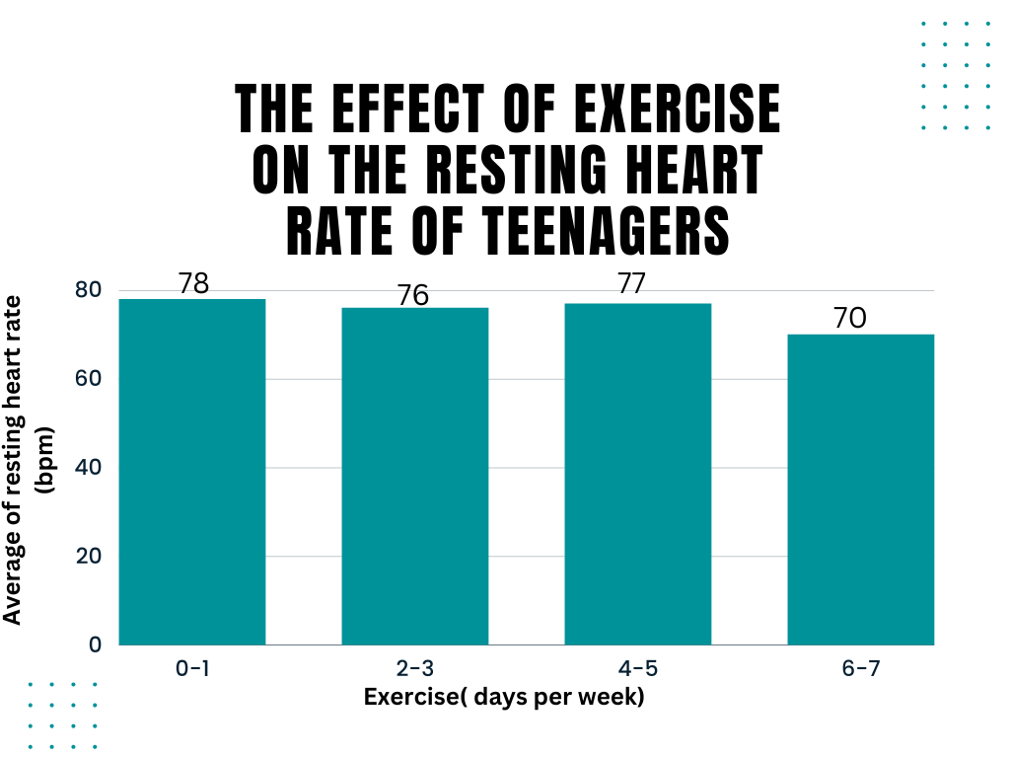

**References:**

*1.Does exercise lower the heart rate? | Livestrong* (no date) *LIVESTRONG.COM*. Leaf Group. Available at: <https://www.livestrong.com/article/388284-does-exercise-lower-the-heart-rate/>.

2.Vega, A.D.de la (2021) *Normal pulse rate for teenagers*, *Healthfully*. Available at: <https://healthfully.com/normal-pulse-rate-teenagers-5422487.html> .

3.*Cardiovascular diseases (cvds)* (no date) *World Health Organization*. World Health Organization. Available at: <https://www.who.int/news-room/fact-sheets/detail/cardiovascular-diseases-(cvds>).

4. *Exercise* (no date) *The Free Dictionary*. Farlex. Available at: <https://medical-dictionary.thefreedictionary.com/exercise> .